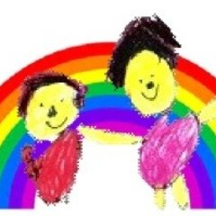

**Literacy**

Read individual letters by saying the sounds for them

Blend sounds into words, so that they can read short words made up of known letter– sound correspondences.

Re-read these books to build up their confidence in word reading, their fluency and their understanding and enjoyment.

Form lower-case and capital letters correctly

**Communication and Language**

Understand how to listen carefully and why listening is important.

Learn new vocabulary.

Develop social phrases.

Listen carefully to rhymes and songs, paying attention to how they sound.

**Mathematics**

Count objects, actions and sounds. Subitise (to 5)

Link the number symbol (numeral) with its cardinal number value (to 10)

Understand the ‘one more than/one less than’ relationship between consecutive numbers (to 10)

**Understanding the World**

Talk about members of their immediate family and community.

Name and describe people who are familiar to them.

**Personal, Social and Emotional**

See themselves as a valuable individual.

Build constructive and respectful relationships.

Manage their own needs. (Wash hands and go to the toilet).

**Expressive Arts and Design**

Sing in a group or on their own, increasingly matching the pitch and following the melody.

Develop storylines in pretend play.

Explore and engage in music making and dance, performing solo or in groups.

**Physical Development**

Use their core muscle strength to achieve a good posture when sitting at a table or sitting on the floor.

Confidently and safely use a range of large and small apparatus indoors and outside, alone and in a group.

Further develop the skills they need to manage the school day successfully: - lining up and queuing - mealtimes - personal hygiene