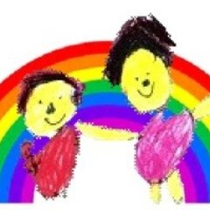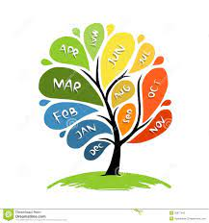

**Literacy**

Re-read what they have written to check that it makes sense.

**Mathematics**

Continue, copy and create repeating patterns.

Compare length, weight and capacity.

**Physical Development**

Know and talk about the different factors that support overall health and wellbeing: regular physical activity, healthy eating, tooth brushing, sensible amounts of screen time, having a good sleep routine, being a safe pedestrian.

Develop the overall body strength, co-ordination, balance and agility needed to engage successfully with future physical education sessions and other physical disciplines including dance, gymnastics, sport and swimming.

Revise and refine the fundamental movement skills they have already acquired; rolling, walking, crawling, skipping, hopping, running, jumping and climbing.

**Understanding the World**

Describe what they see, hear and feel outside.

Recognise some similarities and differences between life in this country and life in other countries.

Recognise that people have different beliefs and celebrate special times in different ways.

Explore the natural world around them.

Comment on images of familiar situations in the past.

Compare and contrast characters from stories, including figures from the past.

**Personal, Social and Emotional**

Manage their own needs.

Express their feelings and consider the feelings of others.

.

**Communication and language**

Engage in non-fiction books.

Listen to and talk about selected non-fiction to develop deep familiarity with new knowledge and vocabulary.

Engage in story times.

Listen to and talk about stories to build familiarity and understanding.

Retell the story, once they have developed a deep familiarity with the text; some as exact repetition and some in their own words.

Use new vocabulary throughout the day.

Ask questions to find out more and to check they understand what has been said to them.

**Expressive Arts and Design**

Watch and talk about performance art, expressing their feelings and emotions.