[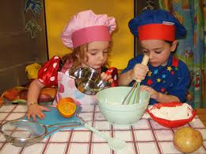](http://images.google.com/imgres?q=children+cooking&start=249&num=10&hl=en&biw=1280&bih=619&addh=36&tbm=isch&tbnid=-39jV3xWWI-98M:&imgrefurl=http://www.busybeeschildcare.co.uk/Cookery-is-Top-Class-at-Busy-Bees-n-1577&docid=4DUiKP6OYRVchM&imgurl=http://www.busybeeschildcare.co.uk/articleimg/cooking-with-me-2010.jpg&w=450&h=337&ei=Muk0UPG-Oo62hAeHzoCQDg&zoom=1&iact=hc&vpx=282&vpy=288&dur=3509&hovh=194&hovw=260&tx=114&ty=109&sig=113439460810528103774&page=11&tbnh=124&tbnw=156&ndsp=25&ved=1t:429,r:7,s:249,i:194)

**Talk to Me**

**Cooking**

Encourage your child to join in.

Talk about what you are making and give your child simple jobs to do such as washing the vegetables or mixing cold ingredients together.

Encourage your child to make their own pretend meals using vegetable peelings or even outdoors with mud and natural items in old pots and pans.