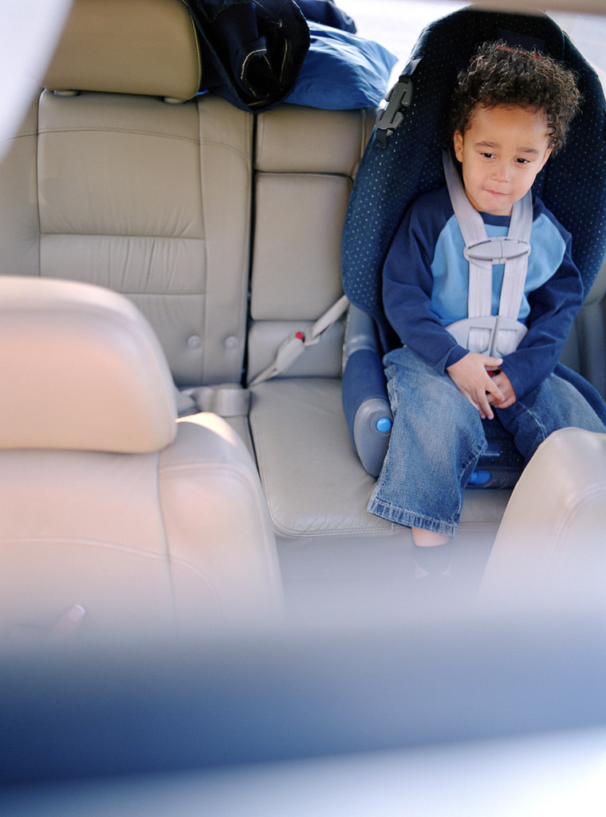

**Talk to Me**

**Going on a car journey**

Talk about where you are going.

Have fun together singing songs and rhymes such as ‘The wheels on the bus’.

Look for different things as you go along such as: People wearing a hat; Red cars; Motorbikes.

Give your child lots of praise and encouragement.